Activity 2 – Vocabulary Exercises.

1. **Match the flag with the country*:***

France China Greece The United States of America Italy

Great Britain Australia Germany Turkey Spain

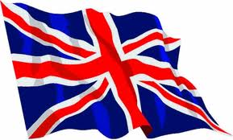 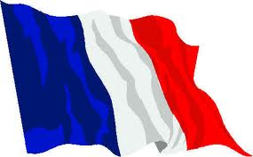 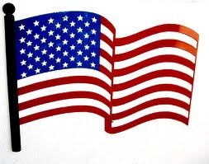 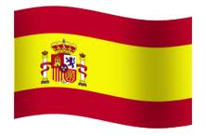 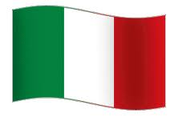

Great Britain France The United States Of America Spain Italy

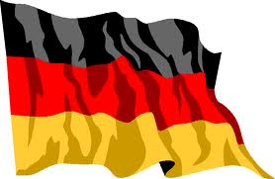 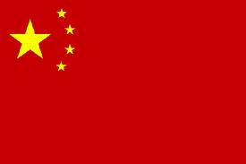 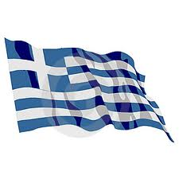 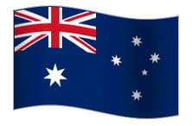 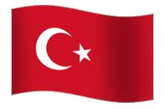

Germany China Greece Australia Turkey

1. **Match the character with the nationality*:***

American French Australian Greek Turkish

German Italian Japanese British Chinese

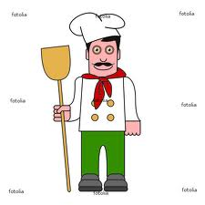  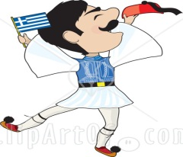 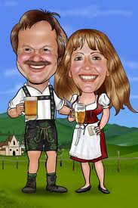 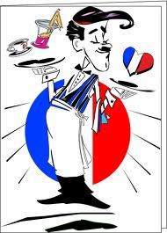

Italian American Greek German France

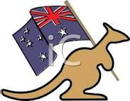   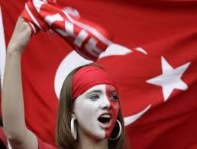 

Australian British Japanese Turkish Chinese

|  |
| --- |
| **3. Study the dialogue below.**  **A: Where are you from?**  **[PRONUNCIATION: uer ar iu from?]**  **B: I’m from Moscow. I’m Russian.**  **[PRONUNCIATION: aim from Moscou. Aim Roshian]**    Now is your turn. Fill in the blanks with your own information and practice the pronunciation.  **A: Where are you from?**  **[PRONUNCIATION: uer ar iu from?]**  **B: I’m from _Mexico_. I’m _mexican_.**  **[PRONUNCIATION: Aim from _Mexico_. Aim _mexican_].** |

1. **Research the name of other countries and nationalities. Write them into the table.**

|  |  |  |  |
| --- | --- | --- | --- |
| Country | Nationality | Country | Nationality |
| Canada | Canadian | **Brazil** | Brazilian |
| England | English | **United Kingdom** | British |
| Scotland | Scottish | **Israel** | Israeli |
| Argentina | Argentine | **Bolivia** | Bolivian |
| Cambodia | Cambodian | **Chile** | Chilean |
| Vietnam | Vietnamese | **Denmark** | Danish |
| Colombian | Colombian | **Ecuador** | Ecuadorian |
| Korea | Korean | **Norway** | Norwegian |
| Malaysia | Malaysian | **Cuba** | Cuban |
| Russia | Russian | **Ukraine** | Ukrainian |